Superovulation
Treatment of a female with gonadotropins (generally FSH) to increase the number of oocytes that are selected to become dominant follicles and ovulate.
A typical treatment response in cattle would be 8 to 10 ovulation
Superovulation Procedures
Hormones used for superovulation
FSH ( Follicle stimulating hormone)
Short half life ̴ 2 hours
PMSG (pregnant mare serum gonadotropi ; eCG
Long half life ̴ 2 – 4 days
Table (1): FSH dosage for superovulation of cattle
 | Bos Taurus |  | Bos Indicus |  | Heifers
 | AM | PM | AM | PM | AM | PM
Day 1 | 5 mg | 5 mg | 4mg | 4mg | 3mg | 3mg
Day2 | 4mg | 4mg | 3mg | 3mg | 3mg | 3mg
Day3 | 3mg | 3mg | 2mg | 2mg | 2mg | 2mg
Day4 | 2mg | 2mg | 2mg | 2mg | 2mg | 2mg
Total | 28 mg |  | 22mg |  | 20 mg

Steps of embryo transfer in cows
Synchronization of recipients with donor
Goal: want donor and recipient to be in same stage of estrus cycle
Reason: preparation of recipient uterus to support embryogenesis
How: treat recipient with synchronization protocol that induces estrus to occur at same time as the donor

Superovulation of donor female
Goal: hyper stimulate ovaries with gonadotropins
Reason: provide higher than normal number of follicles that will ovulate
How: inject with FSH

Inseminate donor with semen from genetically superior bull
Goal: to generate the best fertilization rates and genetic combinations possible
Reason: enhance rate of genetic progress
How: utilize highly fertile semen and trained inseminators

Recovery and identification of viable embryos
Goal: nonsurgically collect (flush) embryos from donor for transfer
Reason: to recover viable embryos
How: block with local anesthetic to relax rectum, at day 6 – 8 a Foleys catheter is inserted into uterus and inflated to prevent retrograde flow of flushing medium, introduce medium, lavage uterus and collect fluid.

Transfer of viable embryos into synchronized recipients
Goal: to deposit a potentially viable embryo into the uterine horn of each recipient
Reason: to achieve pregnancy in each recipient
How: a single embryo is placed into the uterine horn ( ipsilateral to the CL) using a transfer pipette

Embryo grading
Criteria for classifying embryos
- Even number of cells
- Uniform division
- Healthy zona pellucid

Embryo Quality
- Excellent
- Good
- Fair
- Poor
- Degenerate

Table (2): Summary of events in super ovulation and embryo transverse?
Estrus day | Donor cow | Recipient cow
9 | 6mg FSH at 7am and 7pm
10 | 25 mg FSH at 7am and 7pm | 25 mg PGF2α 7pm
11 | 4 mg FSH at 7am and 7pm  25 mg PGF2α at 7pm
12 | 3 mg FSH at 7am and 7pm
13 if not is estrus | 2 mg FSH at 7am and 7pm
13 -15 | estrus
Onset of estrus | inseminate
Onset of estrus +12h | inseminate
Onset of estrus+24h | inseminate | Transverse embryo
7 new cycle | Collect and evaluate embryo with inject PGF2α into donor after flush

Table (3): superovulation and embryo transverse programs by using PMSG
Estrus days | Donor cow | Recipient cow
10 | PMSG 2500 IU
12 | PGF2α 25mg | PGF2α 25mg
14 estrus | inseminate
7 day after estrus | Uterine flushing | Embryo transverse

Table (4): Embryo transverse programs by FSH
Estrus day | Donor cow | Recipient cow
10 | FSH 5mg am and 5mg pm
11 | FSH 5mg am and 5mg pm
12 | FSH 5mg am and 5mg pm | PGF2α 25mg
13 | FSH 5mg am and 5mg pm
14 estrus | inseminate
7 day after estrus | Uterine flushing | Embryo transverse

Table (4): Modified Dulbecco phosphate-buffered medium
Part 1
ingredients | Amount for 10 Liters  g
NaCl | 80.0
KCl | 2.0
Na2HPO4 | 11.5
KH2PO4 | 2.0
Glucose | 10.0
Streptomycin sulphate | .5
Na pyruvate | .36
Na penicillin G | 1,000,000 units

Part 2
CaCl2 2H2O | 1.32
MgSO4 7H2O | 1.21

- Dissolve part 1 in 8 liters of deionized, distilled water.
- Dissolve part 2 liters of deionized, distilled.
- Add part 2 to part 1 slowly with constant stirring to prevent precipitation
- Add heat-treated autoserum immediately prior to use: 1% for flushing and 20% for culture.
Note: autoserum (( bovine serum albumin used for recovery and holding media)) this serum heat at 56C for 30 minute, the purpose from heating is remove complement embryo toxic.
- Sterilize by passing through Millipore filters with 0.22µ pores.

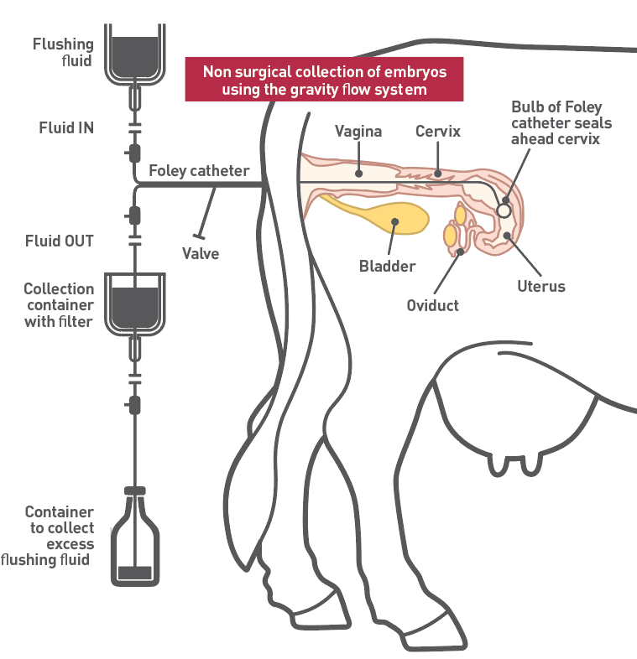

Training manual for embryo transfer in cow

