Spermatogenesis
Spermatogenesis is the process by which spermatozoa are produced from male primordial germ cells through mitosis and meiosis. The initial cells in this pathway are called spermatogonia, which yield primary spermatocytes by mitosis. The primary spermatocyte divides meiotically into two secondary spermatocytes, each secondary spermatocyte then completes meiosiss as it divides into two spermatids. These develop into mature spermatozoa, also known as sperm cells. Thus, the primary spermatocyte gives rise to two cells, the secondary spermatocytes, and the two secondary spermatocytes by their subdivision produce four spermatozoa.
Spermatozoa are the mature male gametes in many sexually reproducing organisms. Thus, spermatogenesis is the male version of gametogenesis. DNA methylation and histone modification have been implicated in the regulation of this process. It starts at puberty and usually continues uninterrupted until death, although a slight decrease can be discerned in the quantity of produced sperm with increase in age.
Spermatogenesis produces mature male gametes, commonly called sperm but specially known as spermatozoa, which are able to fertilize the counterpart female gamete, the oocyte, during conception to produce a single-celled individual known as zygote. This is the cornerstone of sexual reproduction and involves the two ganetes both contributing half the normal set of chromosomes (haploid) to result in a chromosomally normal (diploid) zygote.
To preserve the number of chromosomes in the offspring which differs between species, each gamete must have half the usual number of chromosomes present in other body cells. Otherwise, the offspring will have twice the normal number of chromosomes, and serious abnormalities may result. In humans, chromosomal abnormalties arising from incorrect spermatogenesis can result in Down syndrome and spontaneous abortion.

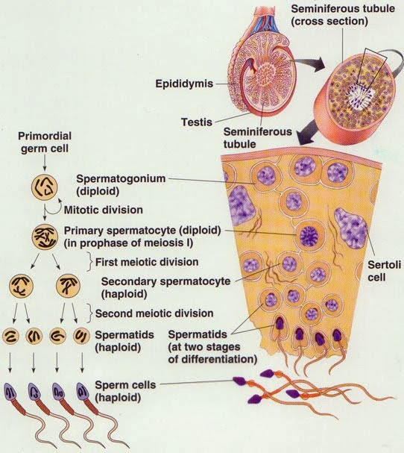

Location
Spermatogenesis takes place within several structures of the male reproductive system. The initial stages occur within the testes and progress to the epididymis where the developing gametes mature and are stored until ejaculation. The seminiferous tubules of the testes are starting point for the process, where stem cells adjacent to the inner tubule wall divide in a centripetal direction beginning at the walls and proceeding into the innermost part, or lumen to produce immature sperm. Maturation occurs in the epididymis.
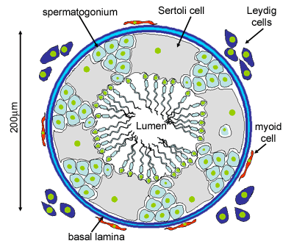
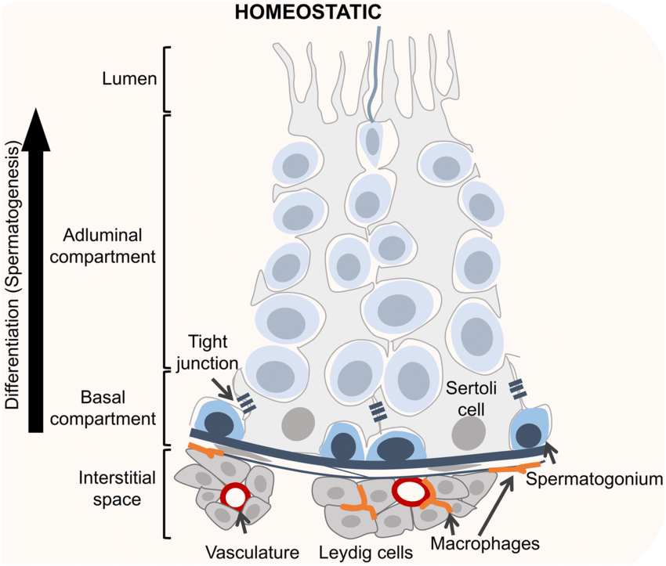

Spermatocytogenesis
Spermatocytogenesis is the male from of gametocytogenesis and results in the formation of spermatocytes possessing half the normal complement of genetic material. In spermatocytogenesis, a diploid spermatogonium which resides in the basal compartment of seminiferous tubules, divides mitotically to produce two diploid intermediate cells called primary spermatocytes. Each primary spermatocyte then moves into the adluminal compartment of the seminiferous tubules and duplicates its DNA and subsequently undergoes meiosis I to produce two haploid secondary spermatocytes, which will later divide once more into haploid spermatids.
Each cell division from a spermatogonium to a spermatid is incomplete, the cells remain connected to one another by bridges of cytoplasm to allow synchronous development. It should also be noted that not all spermatogonia divide to produce spermatocytes, otherwise the supply would run out. Instead, certain types of spermatogonia divide to produce copies of themselves, thereby ensuring a constant supply of gametogonia to fuel spermatogenesis.
Spermatidogenesis
Spermatidogenesis is the creation of spermatids from secondary spermatocytes. Secondary spermatocytes produced earlier rapidly enter meiosis II and divide to produce haploid spermatids.
Spermiogensis
During spermiogensis, the spermatids begin to grow a tail, and develop a thickened mid-piece, where the microtubules gather and form anaxoneme. Spermatid DNA also undergoes packaging, becoming highly condensed. The DNA is packaged firstly with specific nuclear basic proteins, which are subsequently replaced with protamines during spermatid elongation. The resultant tightly packed chromatin is transcriptionally inactive. The golgi apparatus surrounds the now condensed nucleus, becoming the acrosome. One of the centrioles of the cell elongates to become the tail of the sperm.
Maturation then takes place under the influence of testosterone, which removes the remaining unnecessary cytoplasm and organelles. The excess cytoplasm, known as residual bodies, is phagocytosed by suuuounding sertoli cells in the testes. The resulting spermatozoa are now mature but lack motility, rendering them sterile. The mature spermatozoa are released from the protective sertoli cells into the lumen of the seminiferous tubule in a process called spermiation.
The non motile spermatozoa are transported to the epididymis in testicular fluid secreted by the sertoli cells with the aid of peristaltic contraction. while in the epididymis the spermatozoz gain motility and become capable of fertilization.
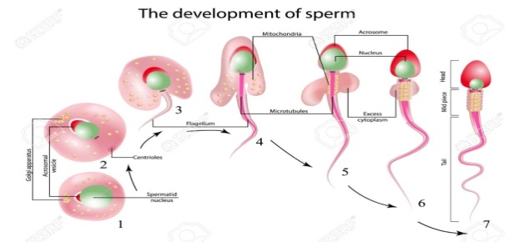

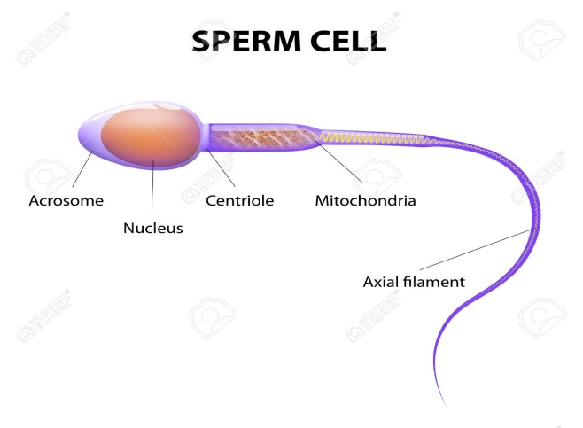

Sertoli cell
At all stages of differentiation, the spermatogenic cells are in close contact with sertoli cells which are thought to provide structural and metabolic support to the developing sperm cells. A single sertoli cell extends from the basement membrance to the lumen of the seminiferous tubule, although the cytoplasmic processes are difficult to distinguish at the light microscopic level.
Sertoli cells serve a number of functions during spermatogenesis, they support the developing gametes in the following ways:
1 – Maintain the environment necessary for development and maturation, via the blood-testis barrier
2 – Secrete substances initiating meiosis
3 – Secrete supporting testicular fluid
4 – Secrete androgen binding protein which concentrates testosterone in close proximity to the developing gametes
5 – Testosterone is needed in very high quantities for maintenance of the reproductive tract and sndrogen binding protein allows a much higher level of fertility
6 – Secrete hormones affecting pituitary gland control of spermatogenesis, particularly the polypeptide hormone, inhibin
7 – Phagocytose residual cytoplasm left over from spermiogensis
8 – They release antimullerian hormone which prevents formation of the mullerian duct / oviduct.
9 – Protect spermatids from the immune system of the male, via the blood testis barrier.

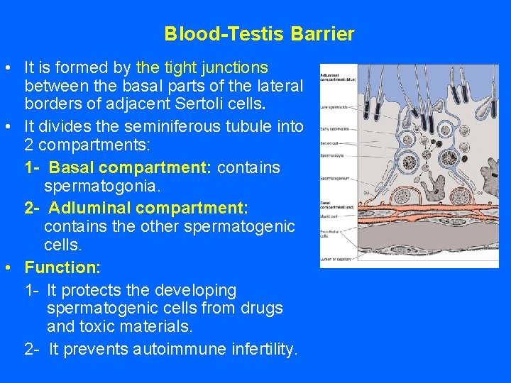
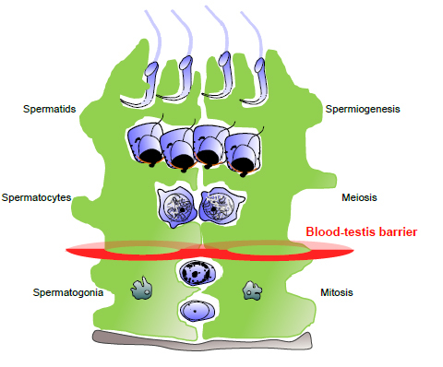

Influencing factors
The process of spermatogenesis is highly sensitive to fluctuations in the environment, particularly hormones and temperature. Testosterone is required in large local concentrations to maintain the process, which is achieved via the binding of testosterone by androgen binding protein present in the seminiferous tubules. Testosterone is produced by interstitial cells, also known as Leydig cells, which reside adjacent to the seminiferous tubules.
Seminiferous epithelium is sensitive to elevated temperature in humans and some other species, and will be adversely affected by temperature as high as normal body temperature. Consequently, the testes are located outside the body in a sack of skin called the scrotum. The optimal temperature is maintained at 2 C men to 8 C mice below body temperature. This is achieved by regulation of blood flow and positioning towards and away from the heat of the body by the cremaster muscle and the dartos smooth muscle in the scrotum.
Dietary deficiencies such as ( B, E, A vitamins ), anabolic steroids, metals ( cadmium and lead ), x- ray exposure, dioxin, alcohol, and infectious diseases will also adversely affect the rate of spermatogenesis. In addition, the male germ line is susceptible to DNA damage caused by oxidative stress, and this damage likely has a significant impact on fertilization and pregnancy.

Peritubular myoid cells in the testis: their structure and function
Peritubular myoid cells, surrounding the seminiferous tubules in the testis, have been found in all mammalian species. Myoid cells contain abundant actin filaments which are distributed in the cells in a species- specific manner. In the rat, the filaments within one myoid cell run both longitudinally and circularly to the long axis of the seminiferous tubule, exhibiting a lattice-work pattern. The arrangement of the actin filaments in the cells changes during postnatal development, and the disruption of spermatogenesis, such as cryptorchidism, seems to affect further the arrangement of the filaments. Other cytoskeletal proteins, including myosin, desmin and alpha actinin, are also found in the cells. Myoid cells have been shown to be contractile, involved in the transport of spermatozoa and testicular fluid in the tubule. Several substances (prostaglandin oxytocin ) have been suggested to affect the contraction of the cell, though the mechanisms of the contraction are still unknown. Peritubular myoid cells not only provide structural integrity to the tubule but also take part in the regulation of spermatogenesis and the testicular function.

Hormonal control
Hormonal control of spermatogenesis varies among species. Initiation of spermatogenesis occurs at puberty due to the interaction of the hypothalamus, pituitary gland and leydig cells. Follicle stimulating hormone stimulates both the production of androgen binding proteinby sertoli cells, and the formation of the blood-testis barrier. Androgen binding protein is essential to concentrating testosterone in levels high enough to initiate and maintain spermatogenesis, which can be 20 – 50 times than the concentration found in blood. Follicle stimulating hormone may initiate the sequestering of testosterone in the testis, but once developed only testosterone is required to maintain spermatogenesis. However, increasing the levels of follicle stimulating hormone will increase the production of spermatozoa by preventing the apoptosis of type A spermatogonia. The hormone inhibin acts to decrease the levels of follicle stimulating hormone. The sertoli cells themselves mediate parts of spermatogensis through hormone production. They are capable of producing the hormones estradiol and inhibin. The Leydig cells are also capable of producing estradiol in addition to their main product testosterone.

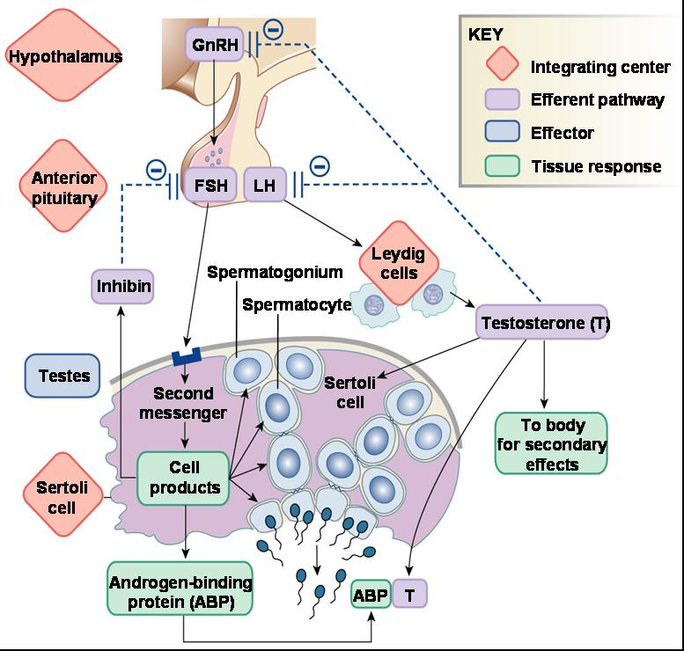

Diagram showing hormonal control in males

A lecture prepared by Dr. Jawad kadhim

