Semen-sexing Technology
Determination of sex at the earliest stage can reduce the management cost thorough selective management of superior bulls or cows. Use of sexed semen fastens the genetic progress and allows the farm manger to increase selectively the number of heifers or steers based on the need of the farm. It also reduces the replacement cost besides maintaining the biosecurity in farm. Techniques for sexing of spermatozoa has been suitably modified and are being used commercially in several countries with about 90% accuracy in cattle. The available technologies have some impediment with respect to cost of production, implementation and pregnancy rate than control sperm. Development of techniques or instruments with high sorting rate and accuracy without damaging the spermatozoa would further hasten the progress of this technology.
Basic Principles of Sex–Selection
Males produce two types of spermatozoa X or Y, when former bearing X sperm fertilizes the egg it results in formation of female and when the egg is fertilized by the Y bearing sperm it results in male offspring. Thus a pragmatic approach to sex pre – selection could be to separate the sperm population containing the desired sex and to use in artificial insemination (AI) programs. This is possible only if we realize the differences between X and Y bearing spermatozoa.
The major difference between the X and Y chromosomes
1- DNA content; the amount of DNA in X chromosome carrying spermatozoa is higher than Y chromosome carrying spermatozoa.
2- Other differences include the size of spermatozoa i.e. X sperm is larger than Y sperm.
3- Motility (motility is reported to be higher in Y chromosome than X chromosome bearing spermatozoa).

4- Surface charges in sperm (X sperm has a negative charge and Y sperm has a positive charge)
5- Cell surface antigens.
Among these differential characteristics, differences in DNA content of spermatozoa have been shown to be the potential criteria for sorting of spermatozoa.

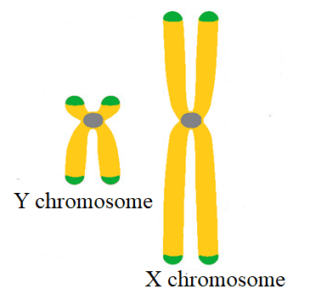
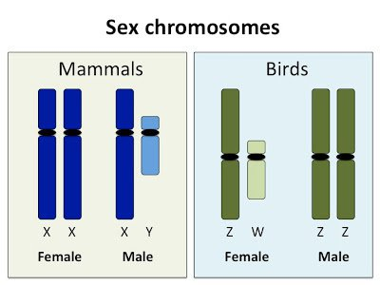

METHODS OF SPERM SEXING
1- Albumin Gradient (or) Gradient Swim Down Procedure

This method is based on the differences between the X and Y bearing spermatozoa in the ability to swim down in a gradient solution. Since Y bearing spermatozoa are smaller in size and have high motility, they exhibit a greater downward swimming velocity than X chromosome bearing spermatozoa. Thus the fractions of semen isolated from specific part of albumin gradient are expected to be either X/Y enriched fractions. Success rate in this method has been reported to be around 75%.
2- Free Flow Electrophoresis
This method is based on the presence of electric charges on the surfaces of spermatozoa. Surface of X spermatozoa are charged negative, while the surface of Y spermatozoa is charged positive. Based on electric field of separation, X and Y spermatozoa were separated using the differences in the surface charges.

3- Percoll Density Gradient Method
Percoll consists of colloidal silica particles coated with polyvinyl pyrrolidine. Percoll is set up in a discontinuous density gradient similar to albumin gradient. Spermatozoa are placed on top of column and centrifugation is done. This method utilizes the differences in the sedimentation density between X and Y bearing spermatozoa. Due to high sedimentation density of X bearing spermatozoa, it settles in the bottom of column while Y bearing spermatozoa remain at the top of column. Success rate in this method ranged from 86% to 94% .

4- Swim Up Procedure
Size – mediated difference of spermatozoa was utilized by several researchers for sperm sorting through different methods. Y bearing spermatozoa are reported to swim faster than X bearing spermatozoa due its smaller size. Success rate in this method was reported to be 81%.

5- Identification of H–Y Antigen

Identification of surface proteins expressed in either X or Y bearing spermatozoa and using immunological methods to identify and separate X and Y bearing spermatozoa could be an option. This method of sorting can be applied in large scale sperm sorting. Using Specific antibodies against H – Y antigen (expressed in Y bearing spermatozoa) sorting of spermatozoa through affinity chromatography or magnetic bead was tried with efficacy of >90%.
6- Sperm Sorting Based on the Volumetric Differences

This method use image analysis of spermatozoa using interference microscopy to demonstrate a difference in sperm head volume based on the DNA content between X and Y chromosome bearing spermatozoa. A method based on this principle has been developed for sorting live spermatozoa by using interference microscopy optics with a flow cytometer. Success rate in this method has been reported to be <80%.

Flow Cytometry
Flow cytometers are the advanced cell sorters that use LASER to excite fluorescent dye that binds to the DNA in spermatozoa. The DNA percent and DNA specific dye are the major principle for sperm sexing through flow cytometry. In this method of sorting, the spermatozoa sample are treated with dye (e.g. Hoechst 33342: 8µl /ml), the suspension is incubated at 35C for 1 hours to assist penetration of stain through membrane ,which is permeable to live and intact sperm membranes and binds to the DNA. Stained spermatozoa are transported to a point where they are exposed individually to a UV laser beam (wavelength of 351 – 364 nm) and the bright blue fluorescence emitted is detected and analyzed. Due to more DNA content in X chromosome bearing spermatozoa, it takes more stain than Y sperm. On the basis of this fluorescence, spermatozoa are classified as X or Y chromosome bearing and sorted. Another dye, commonly called “red quencher food colouring dye”, selectively penetrates into the damaged, dead and non – intact sperm membranes giving a red colour. Identification of live & dead sperm should be done before sorting process. Based on the excitation, spermatozoa are separated into discrete populations. In domestic animals the differences in DNA content between X and Y bearing spermatozoa ranges from 3 – 4.5% (Johnson et al., 1987; Johnson, 2000). Success rate in this method has been reported to be 85 – 95% (Pinkel et al., 1982; Johnson et al., 1989, 2000).
Among the various methods, flow cytometry based separation of sex specific spermatozoa is more popular and no other method has been consistently proven to be effective in producing offspring of the predicted sex till to date.

