Insemination techniques
Successful artificial insemination culminates with the proper placement of high quality semen in the female reproductive tract. The object of insemination technique is to place the semen in the part of the reproductive tract that will give the best chances for conception. The insemination technique is difficult for each of the five farm species. This is due to the size of the females, and to the anatomy of their reproductive systems.
Insemination of the cow
Three basically different methods of inseminating the cow have evolved since the beginning of AI.
1-Vaginal insemination
The earliest inseminations were accomplished by simply inserting a tube into the vagina and depositing semen at the mouth of the cervix. This procedure simulated a deposit of semen during natural mating and probably gave fair results when very large numbers of sperm were deposited. However, the environment of the vagina is not conducive to long life of sperm. Recent research with a limited number of services indicates that a modern breeding unit of semen containing approximately 10 million motile sperm will result in a very low conception rate when deposited in the vagina.
2-Cervical insemination
Cervical insemination is accomplished by inserting a sterile speculum (2cm to 3 cm in diameter and 35 cm to 40 cm long) into the vagina. With the use of a light source (pen light or head lamp), an inseminating instrument can be inserted into the opening of the cervix. Normally the instrument can be inserted from 1 cm to 2 cm and the semen deposited at that point. This method is far superior to the vaginal method but usually gives 10 to 12 percentage units lower conception rate than the recto-vaginal method. Another disadvantage of this method is the amount of equipment that must be sterilized between inseminations.
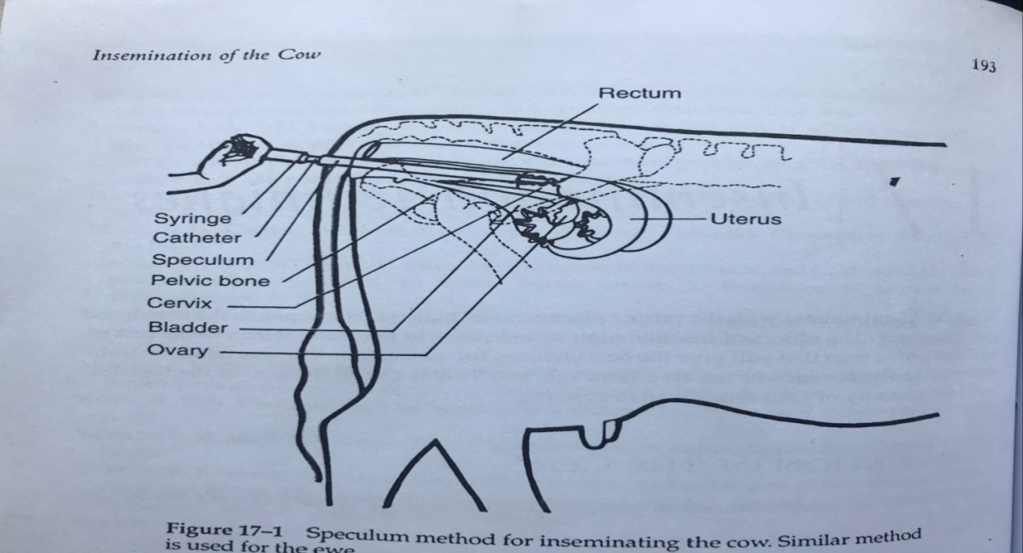

3-Recto-vaginal insemination
The recto-vaginal insemination method is also referred to as the cervical fixation method. While this technique is not complicated, considerable practice with live cows is required to mater it. The authors recommend that beginners take an academic course or a short course that provides hands-on practice. It is accomplished by inserting a gloved left hand, lubricated with a small a mount of surgical jelly, into the rectum of the cow. The hand locates and grasps the cervix. The cervix can be distinguished from the vagina and uterus by its firm, thick walls. The inseminating instrument is inserted through the vulva into the vagina until it contacts the cervix and the left hand. The lips of the vulva should be spread slightly when inserting the inseminating instrument to prevent contamination by the outer surfaces of the vulva. The cervix should be hold by its posterior end with index and middle fingers and thumb, leaving the other two fingers free to help guide the inseminating instrument. The instrument is guided into the opening of the cervix, and the left hand is used to thread the end of the instrument through the irregular cervical channel. The cervical folds make it necessary to manipulate the cervix in all directions in order to pass the instrument through the cervix. As the instrument progresses through the cervix, the fingers and thumb are moved forward so that the manipulation is taking place just forward to the end of the inseminating instrument, progress of the instrument can be determined by the rigidity it gives to the cervix. The inseminating instrument should be stopped as soon as it reaches the anterior end of the cervix.
The inseminating instrument should not be removed from the vagina after insertion until insemination is completed. Extra passages through the lips of the vulva result in greater contamination. It is particularly important not to withdraw the instrument when the cow urinates. The opening would be pointed directly into the oncoming stream of urine, which is extremely detrimental to sperm.

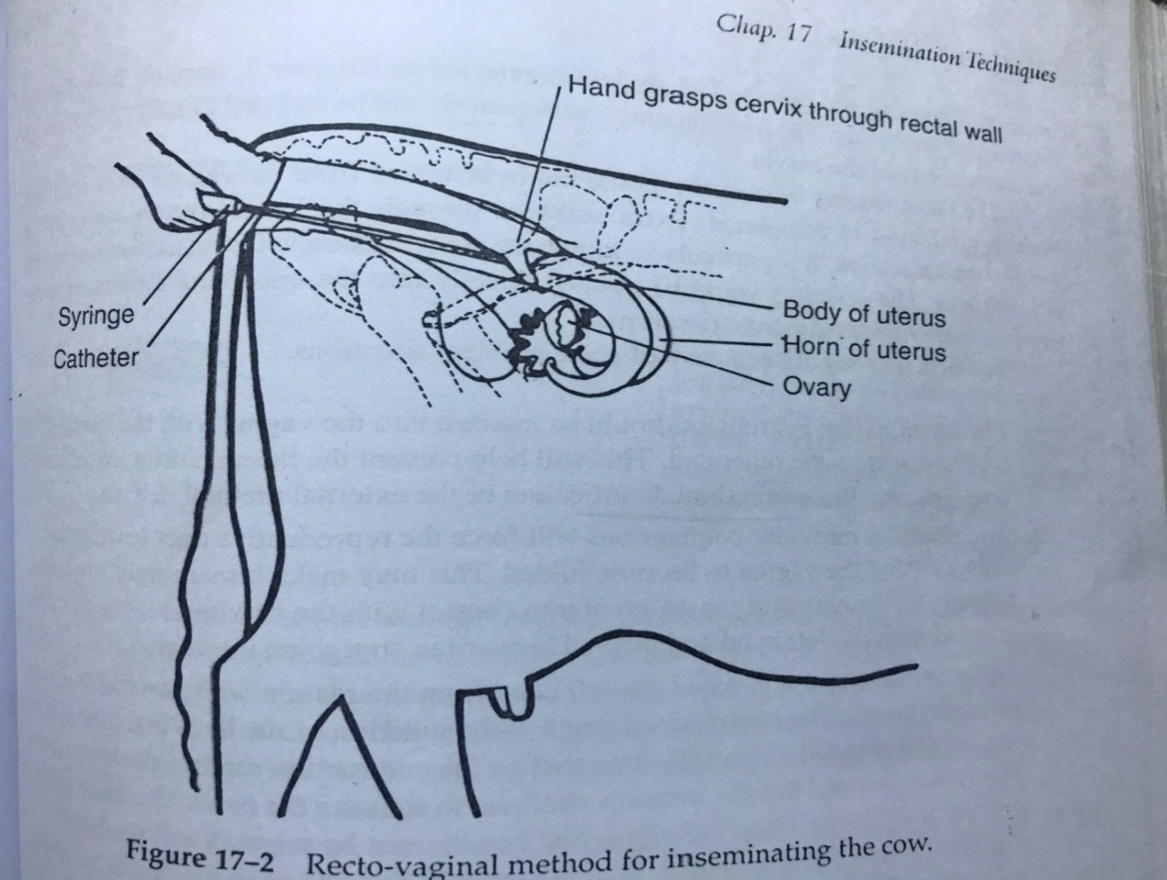

The beginner should be a ware of some problem situations.
1-The insemination instrument should be inserted into the vagina with the forward tip held higher than the other end. This will help prevent the insemination instrument from entering the suburethral diverticulum or the external urethral orifice.
2-Occasionally, muscular contractions will force the reproductive tract toward the anus, causing the vagina to become folded. This may make it seemingly impossible to bring the inseminating instrument into contact with the cervix. The cervix can be grasped with the left hand and pushed forward to straighten the vagina.
3-The cow will attempt to expel the left hand from the rectum with peristaltic muscular contractions. The contractions begin at the junction of the large intestine and the rectum and proceed toward the anus. When the contraction reaches the hand, its progress is stopped but the muscles continue to squeeze the hand. The hand will tire quickly if the contraction is fought. The cervix must be released and the hand pushed through the contraction. The rectum will be released so the cervix can be manipulated again.
4-The rectal muscles may contract, forming a large, hard-walled, tubular structure. The cervix cannot be felt or manipulated through this condition. This contraction can be overcome by reaching forward to the junction of the rectum and large intestine. The fingers can be cupped over the hardened rectal wall and the hand pulled toward the anus. This procedure usually causes the contracted rectal muscle to relax and soften so the cervix can be manipulated.
5-In practice situations the vagina occasionally fills will air, making it difficult to grasp and manipulate the cervix. Firm pressure with the hand toward the vulva will dispel the air and restore favorable working conditions.
6-An extremely full bladder can make working with the cervix difficult. Manipulating the clitoris may cause urination.
The recto-vaginal method is more difficult to learn. However, its superior conception rate makes it the method of choice. Conception rates are lower for the beginner, but as the technique is mastered conception improves.
Inseminating equipment
A plastic inseminating catheter fitted with a polypropylene bulb (poly bulb) or a 2-ml syringe attached to the catheter with a short rubber connecting tube must be used when liquid semen or semen frozen in ampoules is being used. Care should be taken to draw all of the semen from the ampule, and this will require some practice when the poly bulb is used. Care must also be taken not to draw the semen into the syringe when one is used. The semen should be discharged from the inseminating catheter slowly. If an attempt is made to expel the semen quickly, the surface tension between the semen and the inseminating catheter is such that the air will be forced through the semen column, leaving 25% to 50% of the semen in the catheter.
Insemination using semen packaged in the plastic straw requires specially designed equipment. The straw gun is a stainless steel tube with a small stainless steel rod to serve as a plunger. The lumen of the tube is the same diameter as the lumen of the straw except for a chamber in the anterior end, which is large enough to accommodate the external diameter of the straw. This chamber is 1 cm shorter than the straw so that the straw protrudes beyond the end of the gun. The straw is inserted with the plug seal going in first. The electrostatically sealed end is cut perpendicular to the straw with surgical scissors. A plastic sheath is slipped over the end of the straw and the gun. The posterior end of the gun tapers so that a plastic O-ring can be used to hold the sheath in place. The sheath is designed to fit tightly against the end of the straw, forming a seal to prevent the semen from being tapped between the straw and the sheath. The semen is expelled by pushing the stainless steel rod against the straw plug, which then acts as a plunger to deliver the semen to the site of insemination. This positive action ensures maximum delivery of sperm.
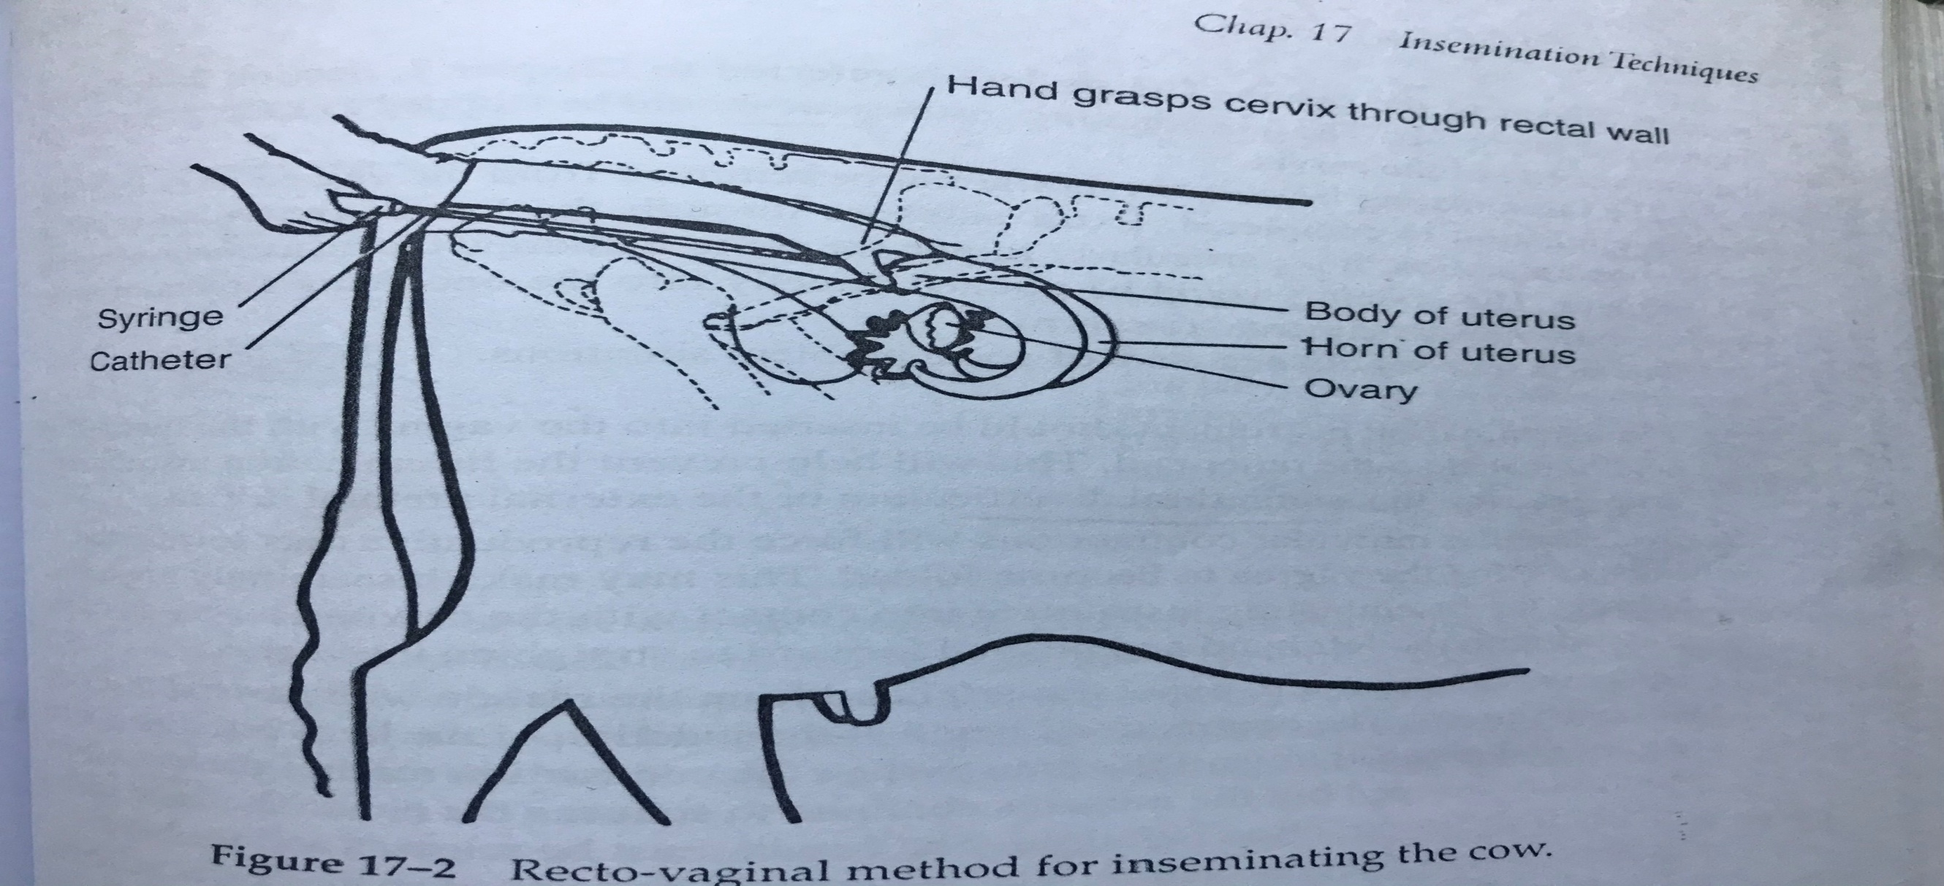
Insemination of the mare
The method used for inseminating mares requires special emphasis on cleanliness, because the hand is placed in the vagina with a finger through the cervix. After confining the mare in a chute suitable to protect the technician, her tail is wrapped with cheesecloth and tied to one side. The vulva, anus, and surrounding area then scrubbed with water and mild soap, with special emphasis on cleaning the creased areas on either side of the vulva. After rinsing with water, the area is dried with sterile guaze. A shoulder length plastic glove is used by the technician with a sterile surgeon's glove worn over the plastic glove. A 50-ml syringe with a volume of semen containing 500 000000 motile sperm is connected to a plastic inseminating catheter. The gloved hand is placed in the vagina with a finger through the cervix, the catheter is passed beside the hand and through the cervix, and the semen is deposited in the body of the uterus. It is easy to pass the catheter through the mare's cervix because it is dilated and softened during estrus. This procedure is used rather than the recto-vaginal method due to the mare's anatomy. The broad ligament is above the cervix and is more distinct than in the cow. Thus, the mare's cervix is more difficult to manipulate via the rectum. Additionally the mares rectum is more delicate and the mucosa is dryer than the cows and a tear is much more serious (usually resulting in death) in the mare.
